

**REPORT FOR PYTHON PROJECT**

**AS A PROJECT WORK FOR THE COURSE**

**PYTHON PROGRAMMING (INT 108)**

**NAME : PRIYASHU KUMAR JHA**

**ROLL NUMBER: 16**

**SUBMITTED TO: Mr. RAJ KARAN SINGH**

**REGISTRATION NUMBER : 12204370**

**DATE OF SUBMISSION: 05/12/2022**

**SCHOOL OF COMPUTER SCIENCE AND ENGINEERING**

**LOVELY PROFESSIONAL UNIVERSITY, JALANDHAR,**

**PUNJAB, INDIA.**

**PROJECT**

**TITLE:**

You need to write a python script that generates an acronym word from a given sentence.

● Take multiple strings as input in the form of list.

● Add the first letter of each string to output.

● Iterate over the complete string and add every next letter to space to output.

● Change the output to uppercase (required acronym).

● You have to generate acronyms for all given strings.

(Student is free to decide the input and output layout for this mini project)

Hint: You can use split and indexing to fetch the first word and then combine it.

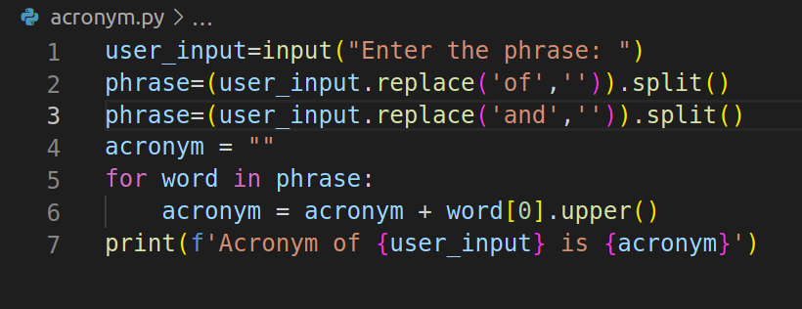**CODE**

**RESULT**

**INPUT 1**



**OUTPUT 1**



**INPUT 2**



**OUTPUT 2**



**PREPARED BY**

|  |  |  |
| --- | --- | --- |
| NAME OF STUDENT | REGISTRATION NO. | ROLL NO. |
| Priyanshu Kumar Jha | 12204370 | 16 |
| Arjun Kallatt | 12216676 | 17 |
| Siddhanth Pandey | 12216768 | 18 |